Assignment - 8
Problem Statement: Beginning with an empty binary search tree, Construct binary search tree by inserting the values in the order given. After constructing a binary tree -Insert new node, ii. Find number of nodes in longest path from root, iii. Minimum data value found in the tree, iv. Change a tree so that the roles of the left and right pointers are swapped at every node, v. Search a value
Objective: To understand the basic concept of Binary Search Tree and its use in Data structure.
Outcome: To construct the Binary Search Tree by given sequence and traverse and perform operations on it.
Software & Hardware Requirements:

- 64-bit Open source Linux or its derivative
- Open Source C++ Programming tool like G++/GCC

Theory –
Binary Search Tree

A Binary Search Tree (BST) is a data structure in computer science that organizes data in a hierarchical manner, where each node holds a value and has at most two child nodes: a left child with values smaller than the parent node and a right child with values larger than the parent node, allowing for efficient searching, insertion, and deletion operations, particularly when the tree is balanced, with an average time complexity of O(log n).

Advantages of Binary search tree
  - Searching an element in the Binary search tree is easy as we always have a hint that which subtree has the desired element.
  - As compared to array and linked lists, insertion and deletion operations are faster in BST.

Example of creating a binary search tree :
Now, let's see the creation of binary search tree using an example.
Suppose the data elements are - 45, 15, 79, 90, 10, 55, 12, 20, 50
  - First, we have to insert 45 into the tree as the root of the tree.

  - Then, read the next element; if it is smaller than the root node, insert it as the root of the left subtree, and move to the next element.
  - Otherwise, if the element is larger than the root node, then insert it as the root of the right subtree.
Now, let's see the process of creating the Binary search tree using the given data element. The process of creating the BST is shown below -

Step 1 - Insert 45.
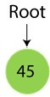
Step 2 - Insert 15.
As 15 is smaller than 45, so insert it as the root node of the left subtree.
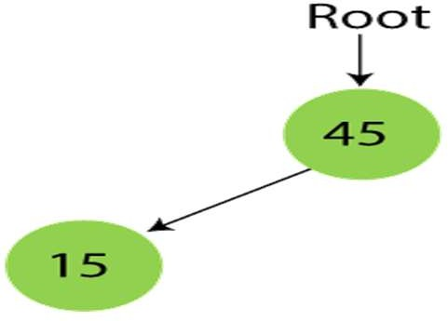

Step 3 - Insert 79.
As 79 is greater than 45, so insert it as the root node of the right subtree.
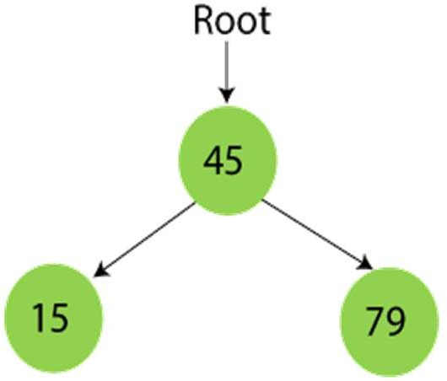

Step 4 - Insert 90.
90 is greater than 45 and 79, so it will be inserted as the right subtree of 79.
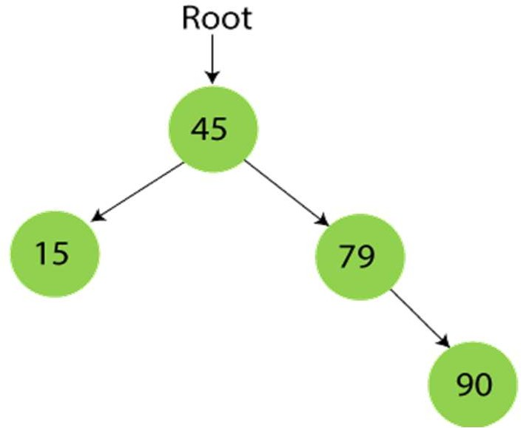

Step 5 - Insert 10.
10 is smaller than 45 and 15, so it will be inserted as a left subtree of 15.
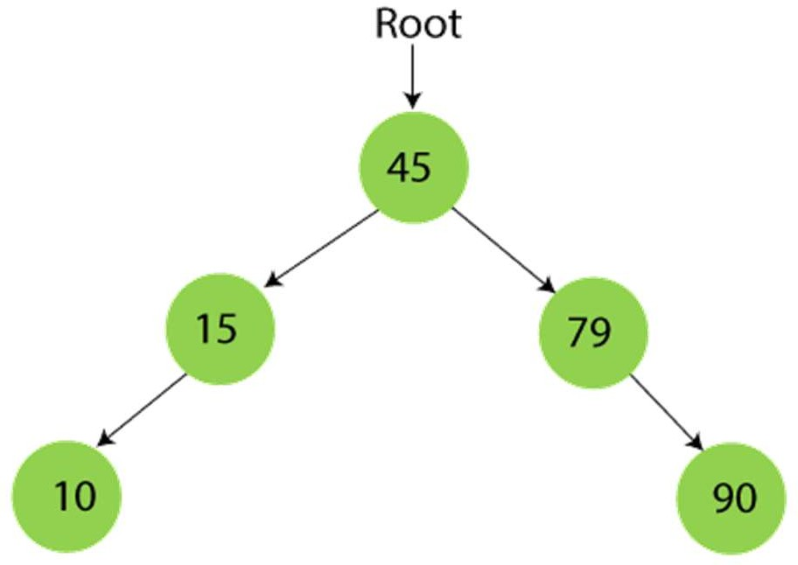

Step 6 - Insert 55.
55 is larger than 45 and smaller than 79, so it will be inserted as the left subtree of 79.
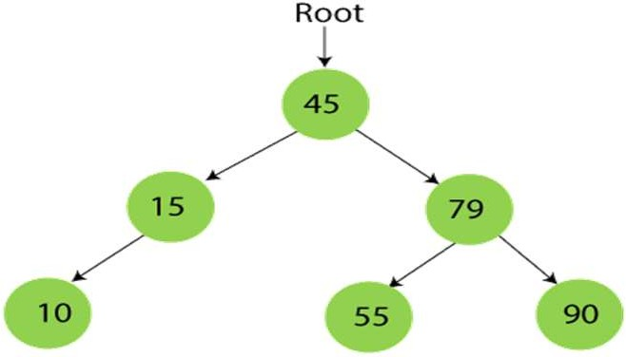

Step 7 - Insert 12.
12 is smaller than 45 and 15 but greater than 10, so it will be inserted as the right subtree of 10.
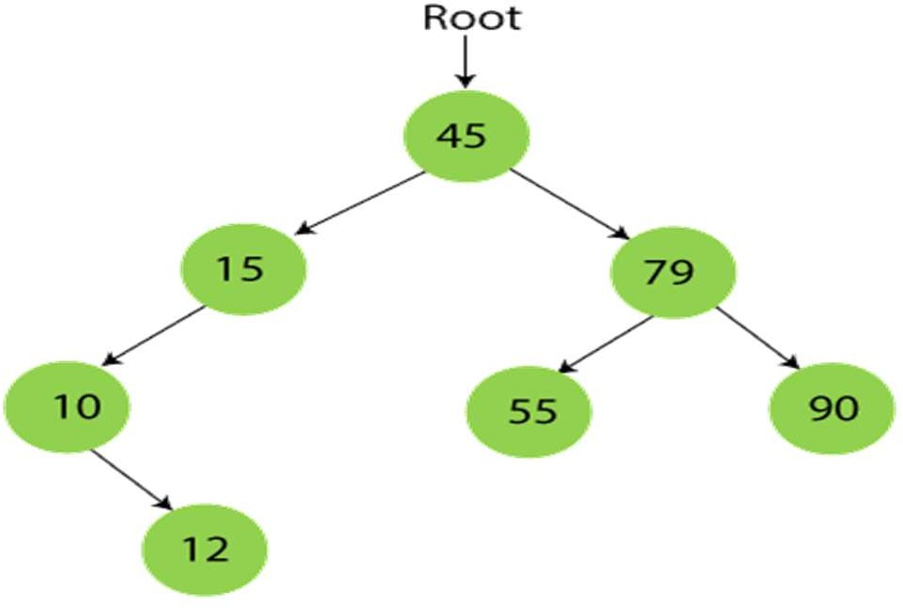

Step 8 - Insert 20.
20 is smaller than 45 but greater than 15, so it will be inserted as the right subtree of 15.
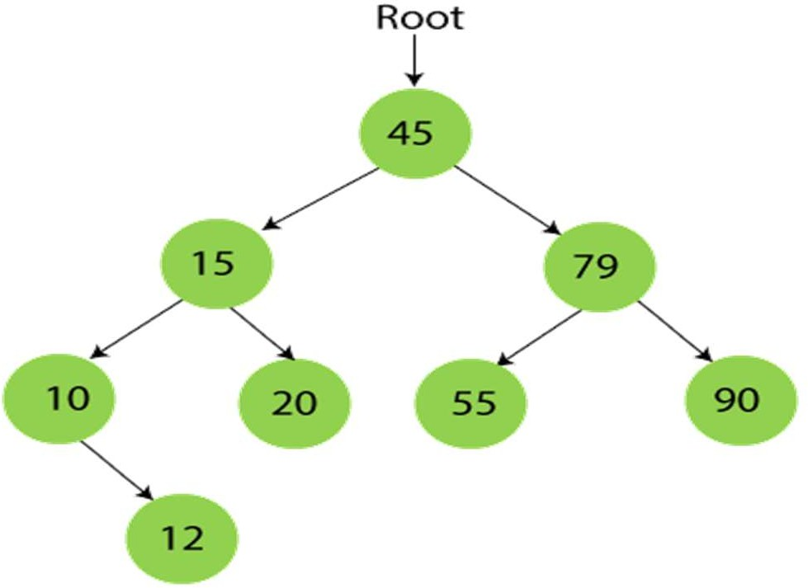

Step 9 - Insert 50.
50 is greater than 45 but smaller than 79 and 55. So, it will be inserted as a left subtree of 55.

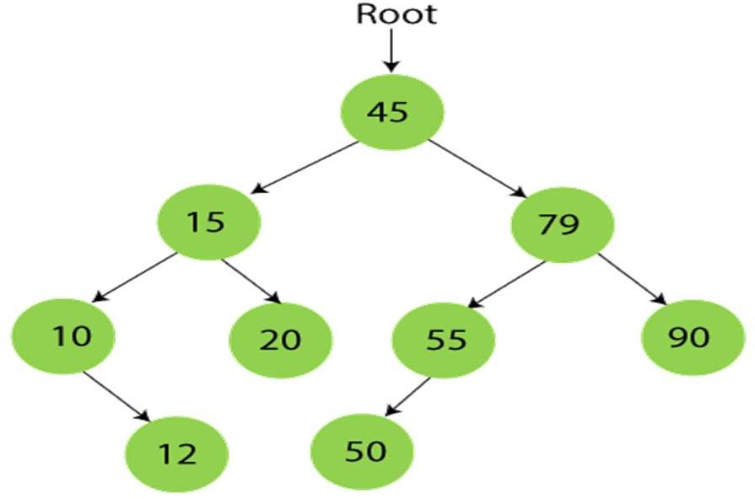
Now, the creation of binary search tree is completed. After that, let's move towards the operations that can be performed on Binary search tree.
We can perform insert, delete and search operations on the binary search tree.

Time Complexity
Operations  Insertion Deletion | Best case time complexity  O(log n) O(log n) | Average case time complexity  O(log n) O(log n) | Worst case time complexity  O(n)  O(n)
Search | O(log n) | O(log n) | O(n)
The space complexity of all operations of Binary search tree is O(n).

Conclusion: We are able to construct the Binary Search Tree by given in order sequence and perform different operations on Binary Search Tree.

